PROJECT TITLE

HOTEL MANAGEMENT SYSTEM

NAME - VEERANKI HARIKA GOUD

STUDENT ID – AF0400955

BATCH – ANP-C7971

# INTRODUCTION:

Hotel Management System is a web-based application that allows the hotel manager to handle hotel room bookings online. Interactive GUI and the ability to manage various hotel bookings and rooms makes this system very flexible and convenient. The Hotel Manager is a very busy person and does not have enough time to sit and manage the entire activities manually on paper. This application is designed to manage and automate various hotel operations, enhancing efficiency, productivity, and customer satisfaction. It gives the power and flexibility to manage the entire system from a single online system.

# ABSTRACT:

Hotel Management project provides room booking, staff management and other necessary hotel management features. The system allows the manager to post available rooms in the system. Customers can view and book room online. Admin has the power of either approving or disapproving the customer’s booking request. Other hotel services can also be viewed by the customers and can book them too. The system is hence useful for both customers and managers to portable manage the hotel activities.

Describing database for Hotel Management System involves several key entities and relationships.

ENTITIES:

* Hotel
* Employees
* Customer
* Rooms
* Payments
* Booking_Status

RELATION BETWEEN ENTITIES:

* Hotel – Rooms: One-to-Many: Hotel owns multiple rooms.
* Room – Customer: One-to-One: Each room can be occupied by many customers.
* Customer – Payments: One-to-Many: One customer can make many payments.
* Employee – Hotel: Many-to-One: Many employees work for hotel.
* Customer – Booking_Status: One-to-Many: One Customer view their booking status of their rooms and price.
* Room – Booking_Status: Many-to-One: Booking status will be decided by checking availability of rooms.

These entities have several attributes which defines the characteristics and behavior of the entities.

1. **Hotel:**

* Hotel_Name
* Location
* Hotel_Id (PK)

1. **Employee:**

* Emp_ID (PK)
* Emp_Name
* Mobile_no
* Job_department
* Address
* Hotel_Id (FK)

1. **Rooms:**

* Room_Category
* Room_no (PK)
* Room_status
* Hotel_Id (FK)

1. **Customer:**

* Name – Fname, Lname.
* Cust_ID (PK)
* D-O-B
* Age
* Address – City, State, Street, Pincode
* Mobile_no
* Room_no (FK)
* Price (FK)

1. **Booking_Status:**

* Date – Start_Date, End_Date
* Price (PK)
* Available_room
* Room_no (FK)
* Cust_ID (FK)

1. **Payments:**

* Payment_Id (PK)
* Payment_Method
* Payment_Amount
* Payment_Date
* Cust_ID (FK)
* Room_no (FK)

ERR DIAGRAM

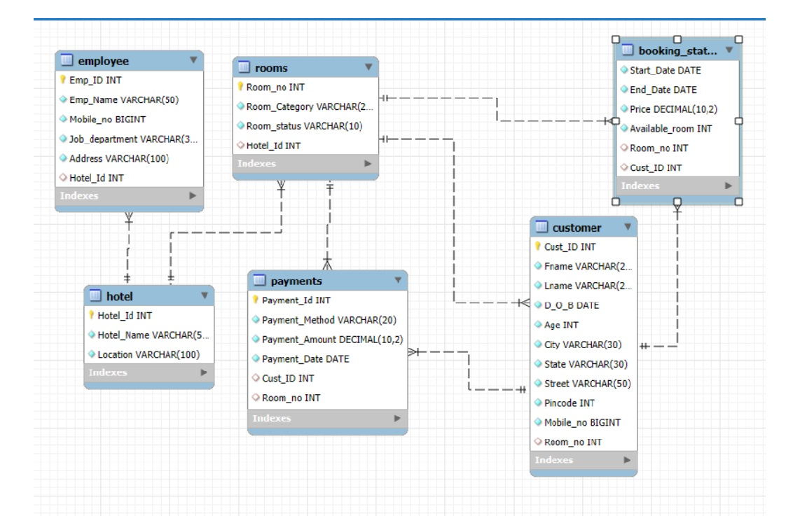

ENTITY RELATIONSHIP DIAGRAM

– HOTEL MANAGEMENT SYSTEM –

**M**

**Works for**

**Employee**

**Hotel**

**1**

**Rooms**

**Owns**

**M 1**

**Depends**

**1/M M**

**Check-in Check-out**

**1/M 1 1 M 1 M**

**views**

**Booking status**

**Make**

**Payment**

**Customer**

**THANK YOU**